Name :Shivam Dolase
PRN:240840320100;
Assignment –1

Creating sample tables and inserting values.

Create the following tables with the given structures and insert sample data as specified: -

- SALESPEOPLE
Snum int(4)
Sname varchar(10)
City varchar(10)
Comm float(3,2)

- CUSTOMERS
Cnum int(4)
Cname varchar(10)
City varchar(10)
Rating int(4)
Snum int(4)

- ORDERS
Onum int(4)
Amt float(7,2)
Odate date
Cnum int(4)
Snum int(4)

mysql> create table SALESPEOPLE(Snum int(4),Sname varchar(10),City varchar(1
0),Comm float(3,2));
Query OK, 0 rows affected, 2 warnings (0.42 sec)

mysql> create table CUSTOMERS(
-> Cnum int(4),
-> Cname varchar(10),
-> City varchar(10),
-> Rating int(4),
-> Snum int(4));
Query OK, 0 rows affected, 3 warnings (0.05 sec)

mysql> create table ORDERS(
-> Onum int(4),
-> Amt float(7,2),
-> Odate date,
-> Cnum int(4),
-> Snum int(4));
Query OK, 0 rows affected, 4 warnings (0.04 sec)
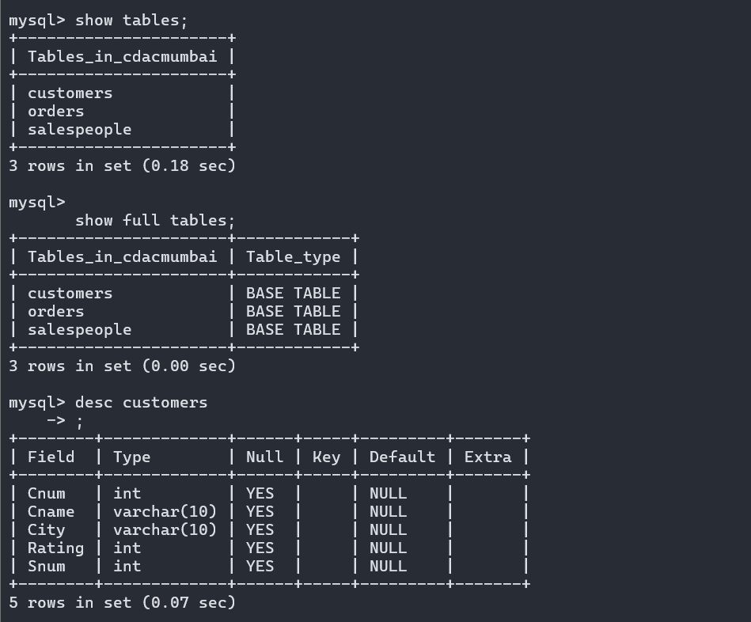

SALES PEOPLE

SNUM | SNAME | CITY | COMM
1001 | Peel | London | .12
1002 | Serres | San Jose | .13
1004 | Motika | London | .11
1007 | Rifkin | Barcelona | .15
1003 | Axelrod | New York | .10

insert into Salespeople values (1001,'Peel','London',.12),(1002,'Serres','San Jose',.13), (1004,'Motika','London',.12), (1007,'Rifkin','Barcelona',.15),
(1003,'Axelord','New York',.10);
CUSTOMERS

CNUM | CNAME | CITY | RATING | SNUM
2001 | Hoffman | London | 100 | 1001
2002 | Giovanni | Rome | 200 | 1003
2003 | Liu | San Jose | 200 | 1002
2004 | Grass | Berlin | 300 | 1002
2006 | Clemens | London | 100 | 1001
2008 | Cisneros | San Jose | 300 | 1007
2007 | Pereira | Rome | 100 | 1004

mysql> insert into Customers values(2001,'Hoffman','London',100,1001), (2002 , 'Giovanni' , 'Rome' , 200 , 1003),(2003 , 'Liu' ,'San Jose' , 200 , 1002),(2004 , 'Grass' ,'Berlin' , 300 , 1002), (2006 , 'Clemens' , 'London' , 100 , 1001),(2008 , 'Cisneros' , 'San Jose' , 300 , 1
007),(2007 ,'Pereira' , 'Rome' , 100 , 1004);

ORDERS

ONUM | AMT | ODATE | CNUM | SNUM
3001 | 18.69 | 03-OCT-1990 | 2008 | 1007
3003 | 767.19 | 03- OCT -1990 | 2001 | 1001
3002 | 1900.10 | 03- OCT -1990 | 2007 | 1004
3005 | 5160.45 | 03- OCT -1990 | 2003 | 1002
3006 | 1098.16 | 03- OCT -1990 | 2008 | 1007
3009 | 1713.23 | 04- OCT -1990 | 2002 | 1003
3007 | 75.75 | 04- OCT -1990 | 2004 | 1002
3008 | 4723.00 | 05- OCT -1990 | 2006 | 1001
3010 | 1309.95 | 06- OCT -1990 | 2004 | 1002
3011 | 9891.88 | 06- OCT -1990 | 2006 | 1001
mysql> insert into Orders values(3001 , 18.69 , '1990-10-03' , 2008 , 1007);

Query OK, 1 row affected (0.01 sec)

mysql> insert into Orders values(3003 , 767.19 , '1990-10-03' , 2001 , 1001);
Query OK, 1 row affected (0.00 sec)

mysql> insert into Orders values(3002 , 1900.10 ,'1990-10-03', 2007 , 1004);

Query OK, 1 row affected (0.01 sec)

mysql> insert into Orders values(3005 , 5160.45,'1990-10-03', 2003 , 1002);
Query OK, 1 row affected (0.01 sec)

mysql> insert into Orders values(3006 ,1098.16,'1990-10-03',2008 , 1007);
Query OK, 1 row affected (0.00 sec)

mysql> insert into Orders values(3009,1713.23,'1990-10-04',2002 , 1003);
Query OK, 1 row affected (0.01 sec)

mysql> insert into Orders values(3007,75.75,'1990-10-04',2004,1002);
Query OK, 1 row affected (0.01 sec)

mysql> insert into Orders values(3008,4723.00,'1990-10-05',2006,1001);
Query OK, 1 row affected (0.00 sec)

mysql> insert into Orders values(3010 ,1309.95 ,'1990-10-06',2004,1002);
Query OK, 1 row affected (0.00 sec)

mysql> insert into Orders values(3011,9891.88,'1990-10-06',2006,1001);
Query OK, 1 row affected (0.01 sec)

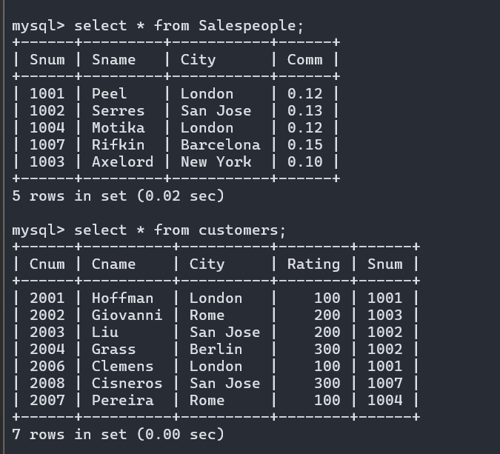
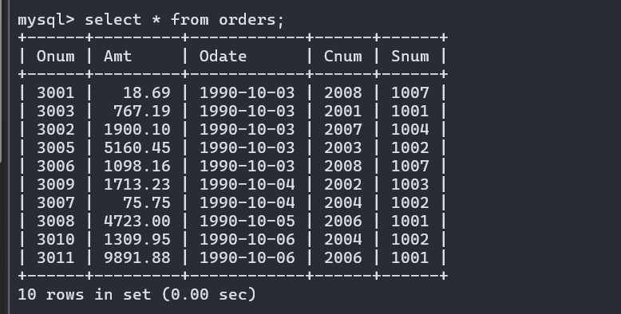

Assignment –2 Introducing Relational Databases.
1) Which field of the Customers table is the primary key?
Answer: CNum column is the primary key of the Customers table;

2) What is the 4th column of the Customers table?
Answer: Rating column is the 4th column of the Customers table.

3) What is another word for row? For column?
Answer: Synonyms for :
Row = [Tuple, Record]
Column = [Field, Attribute]

4) Why isn’t it possible to see the first five rows of a table?
Answer:

Assignment –3
Overview of SQL

1)Does ANSI recognize the data type DATE?
Ans: Yes, ANSI dose recognize data type DATE.

2) Which subdivision of SQL is used to insert values in tables?
Ans: For inserting values in tables we use “insert into” command which belongs to DML (Data Manipulation language) subdivision of SQL.

Assignment –4
Retrieving Information from Tables.
1) Write a select command that produces the order number, amount, and date for all
rows in the Orders table.
Answer:
mysql> select Onum,Amt,Odate from Orders;
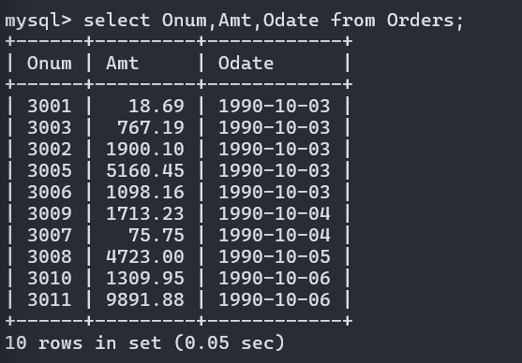|
+------+---------+------------+
2) Write a query that produces all rows from the Customers table for which the
salesperson’s number is 1001.
Answer:select * from customers where Snum=1001;

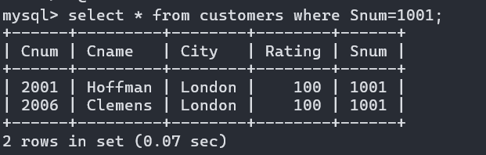
3) Write a query that displays the Salespeople table with the columns in the
following order: city, sname, snum, comm.
Answer: mysql> select City,Snum,Sname,Comm from Salespeople;

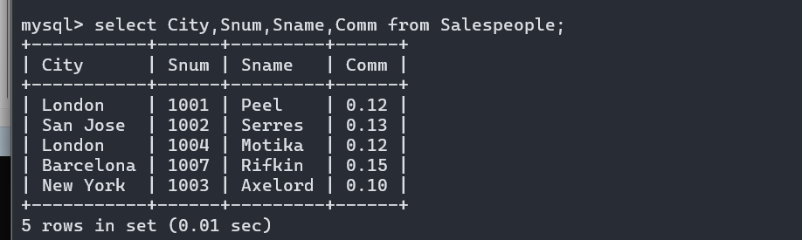

4) Write a select command that produces the rating followed by the name of each
customer in San Jose.
Answer:
mysql> select Rating , Cname from customers where City='San Jose';

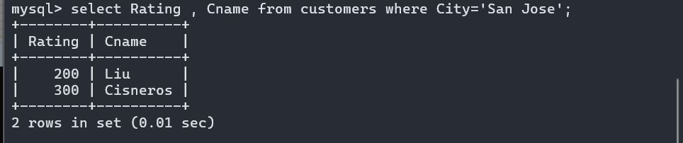
5) Write a query that will produce the snum values of all salespeople (suppress the
duplicates) with orders in the Orders table.snum
Answer: select distinct snum from Orders;

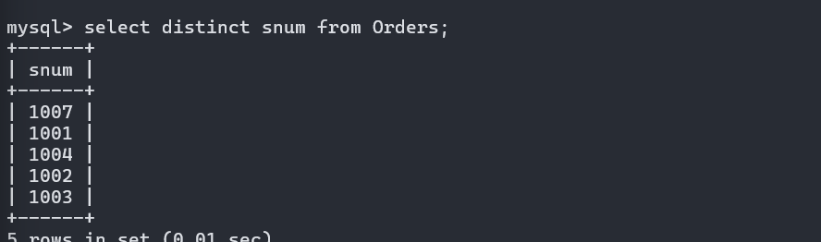

Assignment –5 Relational and Logical
Operators.
1)Write a query that will give you all orders for more than Rs. 1,000.
mysql> select * from Orders where Amt>=1000;
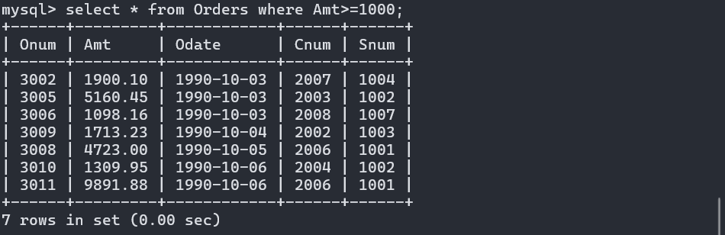

2) Write a query that will give you the names and cities of all salespeople in
London with a commission above .10.
Answer: mysql> select Sname,City from Salespeople where city='London' AND Comm>.10;

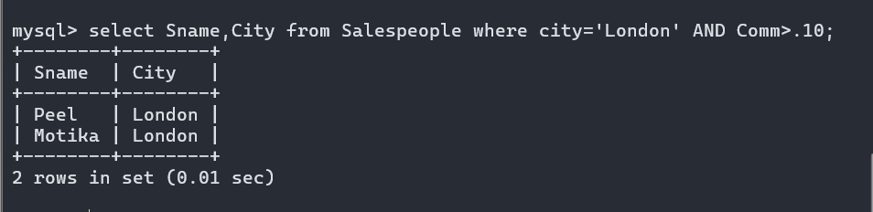
3) Write a query on the Customers table whose output will exclude all customers
with a rating <= 100, unless they are located in Rome.

4) What will be the output from the following query?
Select * from Orders
where (amt < 1000 OR
NOT (odate = ‘1990-10-03’
AND cnum > 2003));
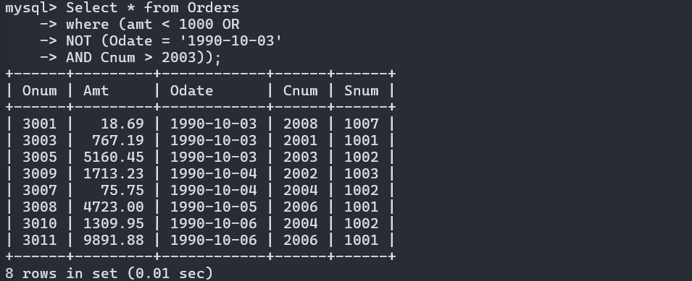

5) What will be the output of the following query?
Select * from Orders
where NOT ((odate = ‘1990-10-03’ OR snum
>1006) AND amt >= 1500);
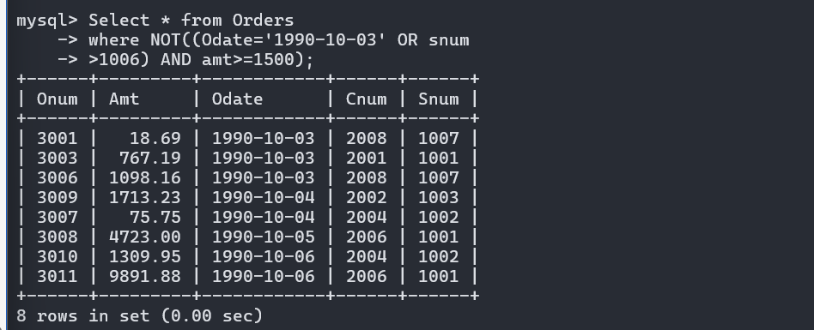
6) What is a simpler way to write this query?
Select snum, sname, city, comm From Salespeople
where (comm > .12 OR comm <.14);
